Depends On Script

What does 'Depends on Script' mean?

Depends on scripts — are the scripts where one script is dependent on the other script.

When do we use Depends on Script?

If any script has to be executed before the execution of a particular script — "**Depends on script**" is used.

Navigation of Depends on Script:

Home icon > Test Development > <<Module name>> > <<Script name>> > Settings > Depends on script

Prerequisites for Depends on Script:

Before creating depends on scripts, "**Module**" should be created, and under "**Module**", and "**Scripts**" under "**Scripts**", "**Steps**" should be created.

Adding Depends on Script

* Click on the “**Depends on Scripts**” button under the "**Settings**" tab inside the Script.

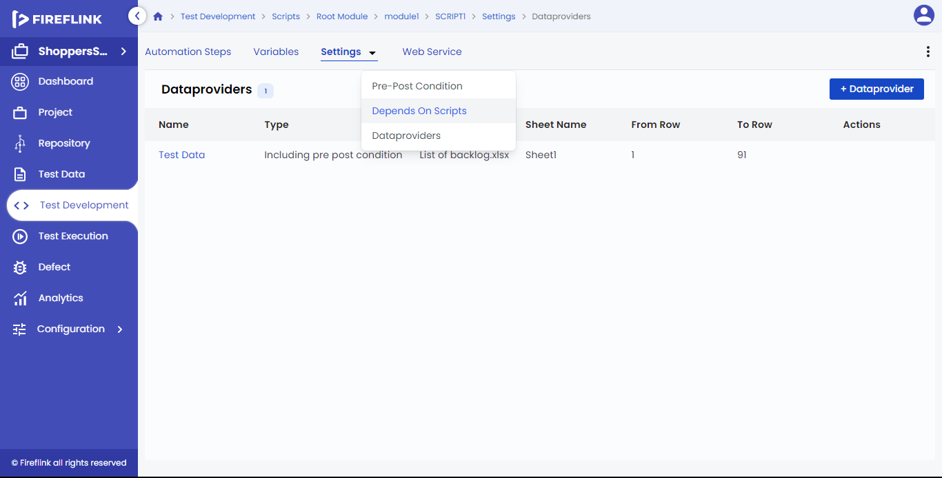

* Click on the "**+ Depends On Scripts**" button.

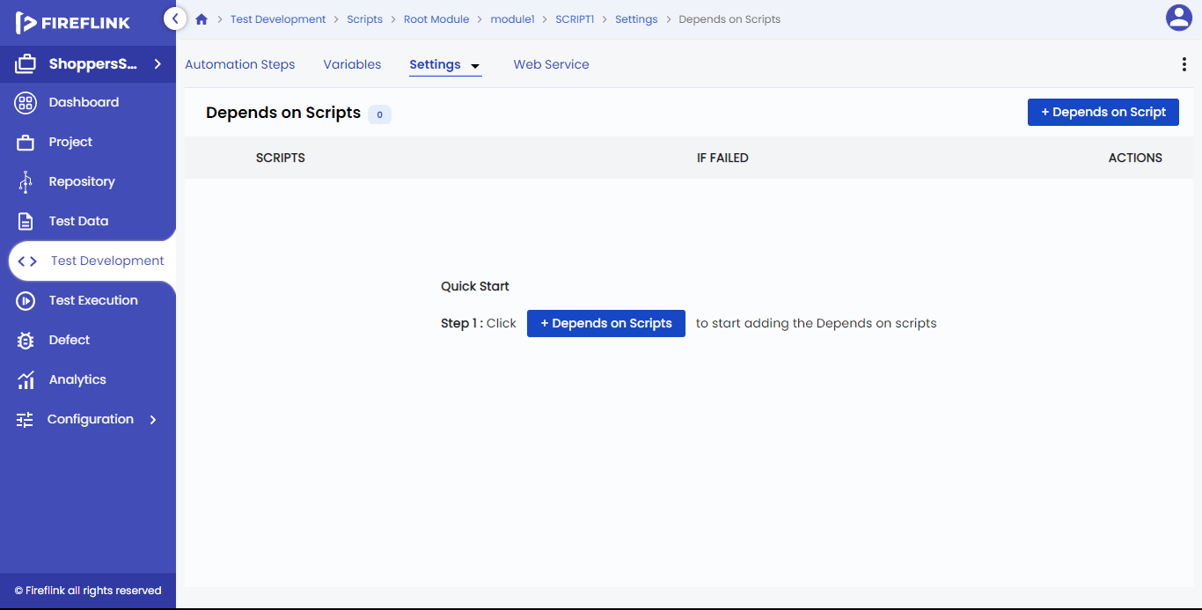

* The **'Add Depends on Scripts'** popup is displayed, which is explained below.

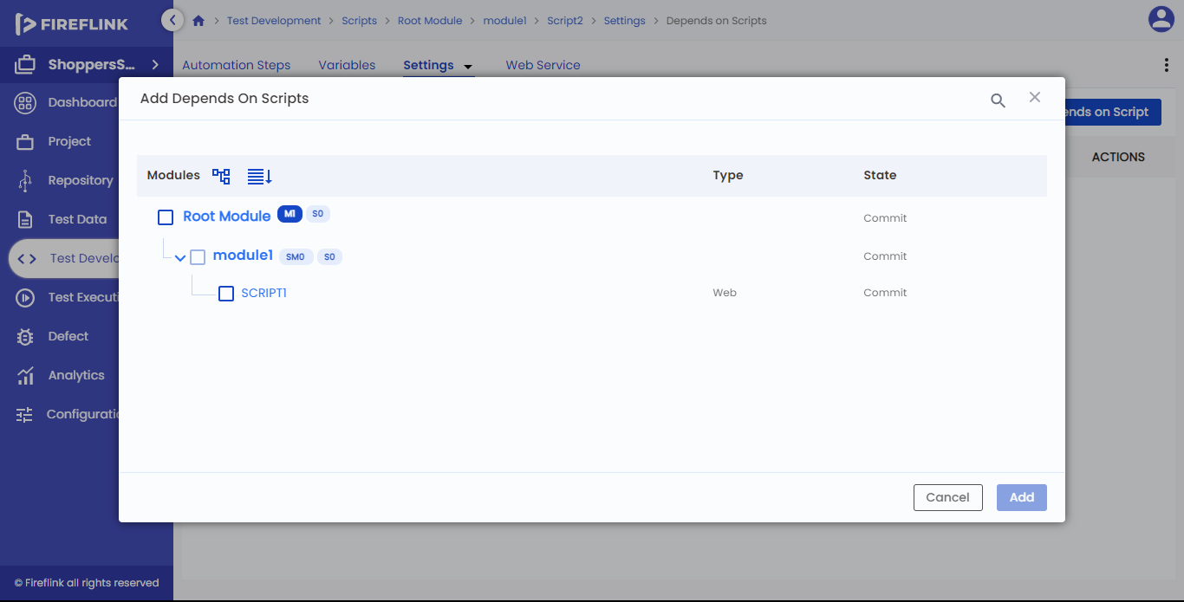

Add Depends on Scripts popup:

* The scripts of the module that are created in the "**Steps**" tab are displayed in the "**Add Depends on Scripts**" popup.
* All the modules and submodules are displayed when clicking on the "**Expand al/ Pages**" icon in the "**Add Depends on Scripts**" popup.
* All the Scripts present under the module tree are displayed by clicking the "**Show all Elements**" icon in the "**Add Depends on Scripts"** popup.
* Users can select the scripts present under a particular module by clicking on a particular checkbox in the "**Add Depends on Scripts**" popup.
* The scripts of the parent level and the scripts of the preceding -sibling can be added as a dependency to the desired script.

Note: -

The scripts of the following siblings cannot be added as a dependency for that particular script.

* While adding a dependency for a particular script, the checkbox of that particular script is disabled because the dependency cannot be added for itself.
* The scripts are displayed in the "**Depends On Scripts**" table after selecting scripts from "**Add Depends on Scripts**" and by clicking on the "**Update**" button.

**NOTE 1: -**

The user cannot add the same script as Dependency in the "Add Depends on Scripts" popup.

**NOTE 2: -**

The checkbox will be disabled, and the scripts for which dependency cannot be added, are in the "Add, Depends on Scripts" popup.

* The script type like "**Web**", "**Database**”, "**IOS**", and "**Web service**" will be displayed in the "Type" column in the "**Add Depends on Scripts”** popup.
* If you click on the "**Add**" button in the "**Add Depends on Scripts**" popup, the data selected will be added to the "**Depends on Scripts**" table.
* If you click on the "**Cancel**" button in the "**Add Depends on Scripts**" popup, it will cancel the operation.

**NOTE 3: -**

Users cannot add dependents on scripts for manual scripts.

* Columns present under the "**Depends on Scripts**" table:

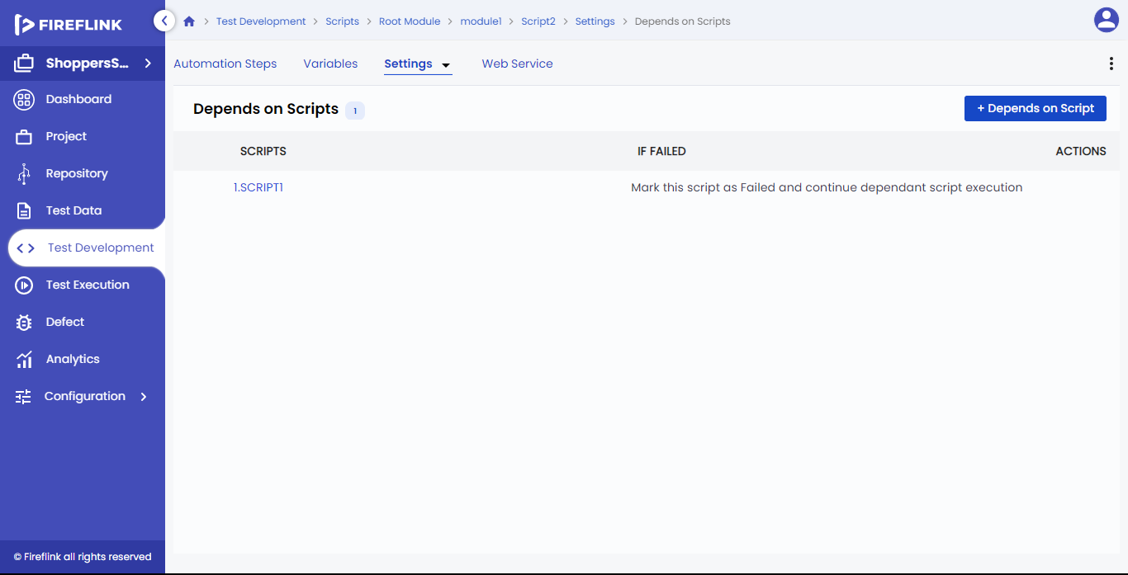

1. Scripts: The scripts selected in the "**Add Depends on Scripts**" popup will be displayed under this column. When you click on the particular script in the table, the "**Depends On Scripts**" div appears in the right section of the page which is explained below.
2. If Failed: The "**If Failed**" option selected from the dropdown in the "**Depends On Scripts div**" will be displayed as static text under this column for the script.
3. Actions: When hovered by the mouse on the script, the "**Delete**" icon is displayed for the particular script. On clicking the "**Delete**" icon it will show a "**Warning**" popup and if clicked on the "**Delete**" button, it is deleted from the table.

Depends On Scripts div: -

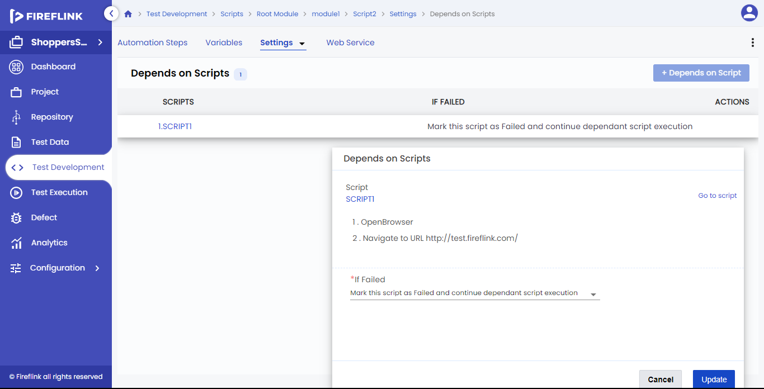

* The steps present under that "**Script**" is displayed in serial order under the **"<Script name)"**
* After adding a dependency for scripts in the "**If failed**" column, if clicked on the dropdown, it will display 5 options, they are:
  1. Mark this script as Failed and continue dependent script execution: Here, the script is marked as failed but will continue the execution of the next dependent script present in the table.
  2. Mark this script as a Warning and continue dependent script execution: Here, the script is marked as a warning but will continue the execution of the next dependent script present in the table.
  3. Mark this script as Failed and stop dependent script execution: Here, the script is marked as failed, and will stop the execution of the next dependent script present in the table.
  4. Mark this script as Failed and stop current module execution: Here, the script is marked as failed, and will stop the execution of all scripts present in that particular module.
  5. Mark this script as Failed and stop complete execution: Here, the script is marked as failed, and will stop the complete execution process.
* After adding a dependency for scripts in the "**Depends on Scripts**" div, and clicking the "**Add**" button, the data will be updated.
* On clicking the "**Cancel**" button, the operation is cancelled.
* Upon clicking on the dependent script added to the table, the user can update the different "**If failed**" conditions. On clicking the "**Update**" button, the dependent script will be updated.